DAY – 4: VIM Editor, User Management:
- VIM Editor
  - Vim <file-name>
  - Entered into the file
  - Press ‘i’ -> insert mode
  - Now enter the text, you can able to type in insert mode.
  - Press “ESC” : esc mode
  - Type-- :q! quite without save
- -:q -> quite
- :wq -> save and qute
- :q! -> quite without save
- :set nu -> display numbers
- :<line-number> -> cursor goes into mentioned line
- :/ <word-to-search> --- top to bottom
- :? <word-to-search> --- bottom to top
- :<line-number>d delete the line
- : %d -> delete everything in the file
- : noh - no highlight (incase previously searched word is still highlight then use this to remove thehighlight.
- :<line-number>s/ <word-to-find>/replace-word -> replaces first occurrence
- :<line-number>s/ <word-to-find>/replace-word/g -> replaces all occurrences
- :%s/ <word-to-find>/replace-word/g -> all occurrences in all lines
- ESC Mode:
  - : gg -> takes to top of the file
  - : shifting+g -> takes us to bottom of the line
  - : u -> undo
  - : ctrl+r -> redo
  - : dd -> deletes the line
  - : yy > copy the line
  - : p -> paste below that line
  - : shift+p -> paste above that line

- User Management:
  - User -> Human
  - Group -> Group humans, teams
  - Roles -> Positions
  - Permissions -> access level to that roles

- $useradd <username>

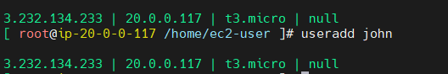
  - To check the user details
- $ id <username>
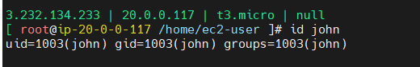
  - A user in linux will have only one primary group and atleast one secondary group
  - When you create a user, group also will be created with same name
- $groupdd <group-name>
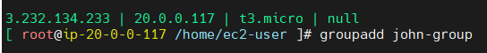
- To check the list of groups
- $ cat /etc/group
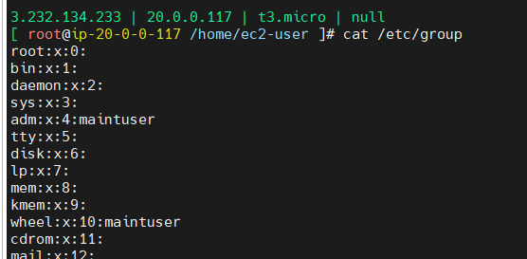
- To add user to a group
- $ usermod -g <group-name> <user-name>

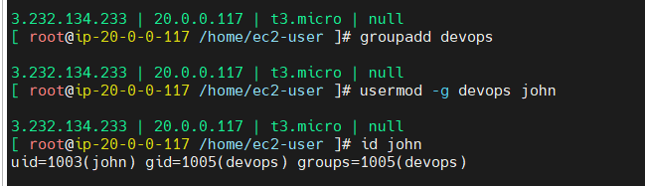
- if you want to add same user in 2 different groups : primary and secondary
- $ usermod -aG <group-name> <user-name>
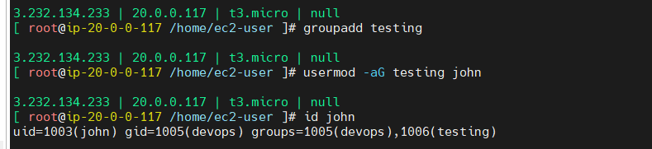
- To set the password for the user
- $ passwd <user-name>
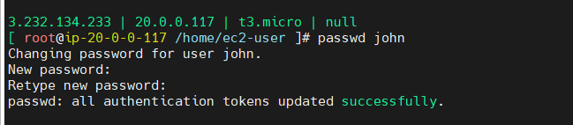

- By default only key-based authentications are enabled.
- How to enable password based authentication in Linux:
- $ sudo vim /etc/ssh/ssh_config
- Search for the line “PasswordAuthentication”.
- Make it “Yes” and save the file.
- Restart the service
  - $ sudo systemctl restart sshd
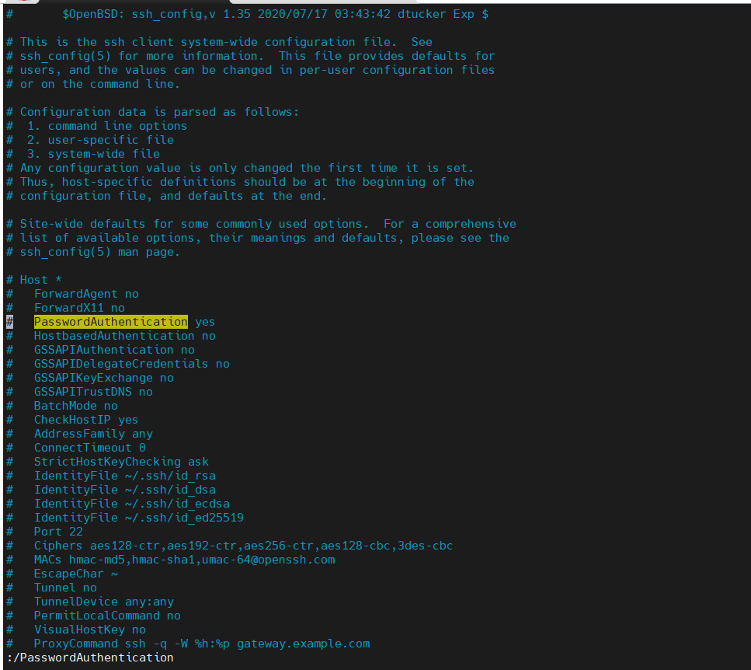
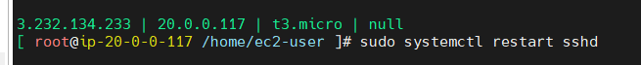
- To verify if there is anything we did wrong in ssh file, then try with this command. If you find any error then there is some wrongly mentioned n ssh_config
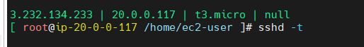

- How to assign root access to the user: (Sudo access)
- Need to do this from root user
- $ sudo su
- # vim /etc/sudoers
- Instead of giving root user access , there is a group called “wheel” which is allow to run all commands.
- Add user to “Wheel” group to provide root access.

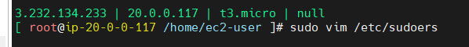
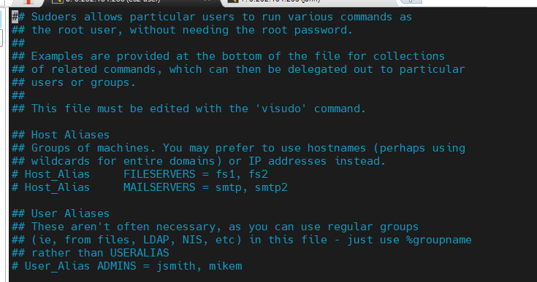

- # usermod -aG wheel john
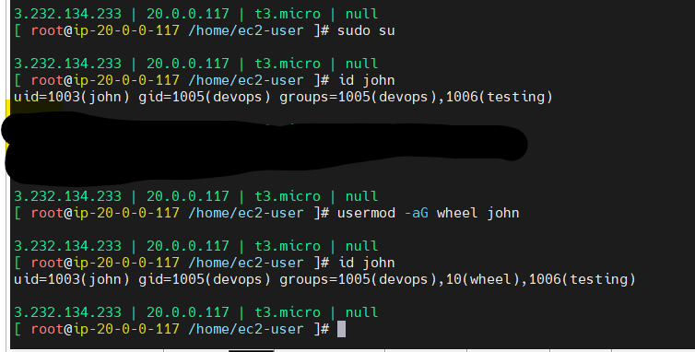
- Then inform user to logout and login the server to effect the permissions

- To know the path of the command
- Ex:
- $ which systemctl
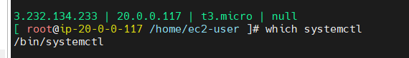

- How to remove user from the group
- $ gpasswd -d <user-name> <group-name>
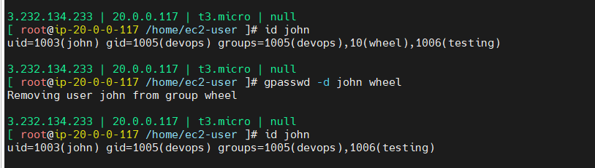

- Instead of providing complete sudo access if you want to allow only specific commands for a user
- Go to /etc/sudoers
- Under wheel group mention the below
- $ username All=(All) <path of the commands>
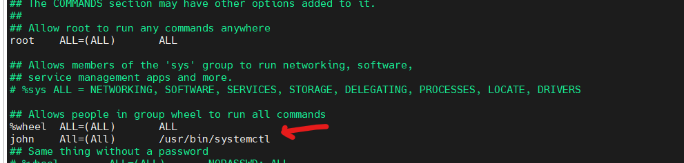
- Use :wq! To save and quite

- If a user is leaving the organization and want to delete the user. Below process step by step
- First lock the user
- $usermod -L <username>
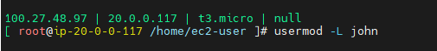
- Remove the user from primary and secondary groups
- $gpasswd -d <user-name> <group-name>
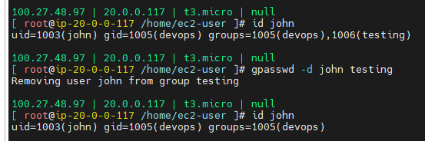
- Now backup the user home folder (using compress method)
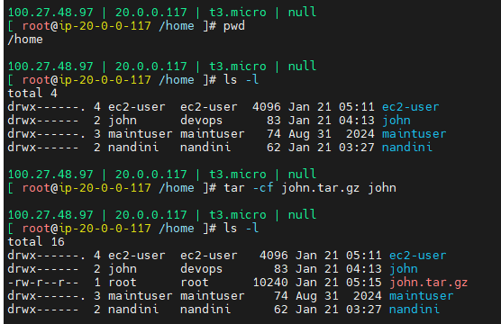
- Delete the user
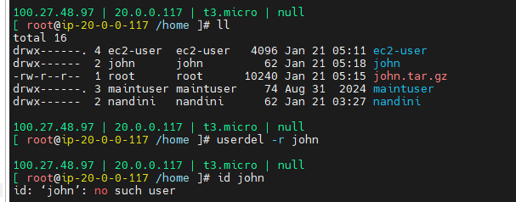

- Compressing the file
- .xzip -> windows compress method
- .gz -> linux compression method
- $ mkdir <test>
- $ tar -cf test.tar.gz test ( compressing the folder/ file -c: creating, -f: filename)
- $ tar -xf test.tar.gz (extracting the file)

